CREATE TABLE category(catcode VARCHAR2(3),catdesc VARCHAR2(11) NOT NULL,

CONSTRAINT category_code_pk PRIMARY KEY (catcode) );

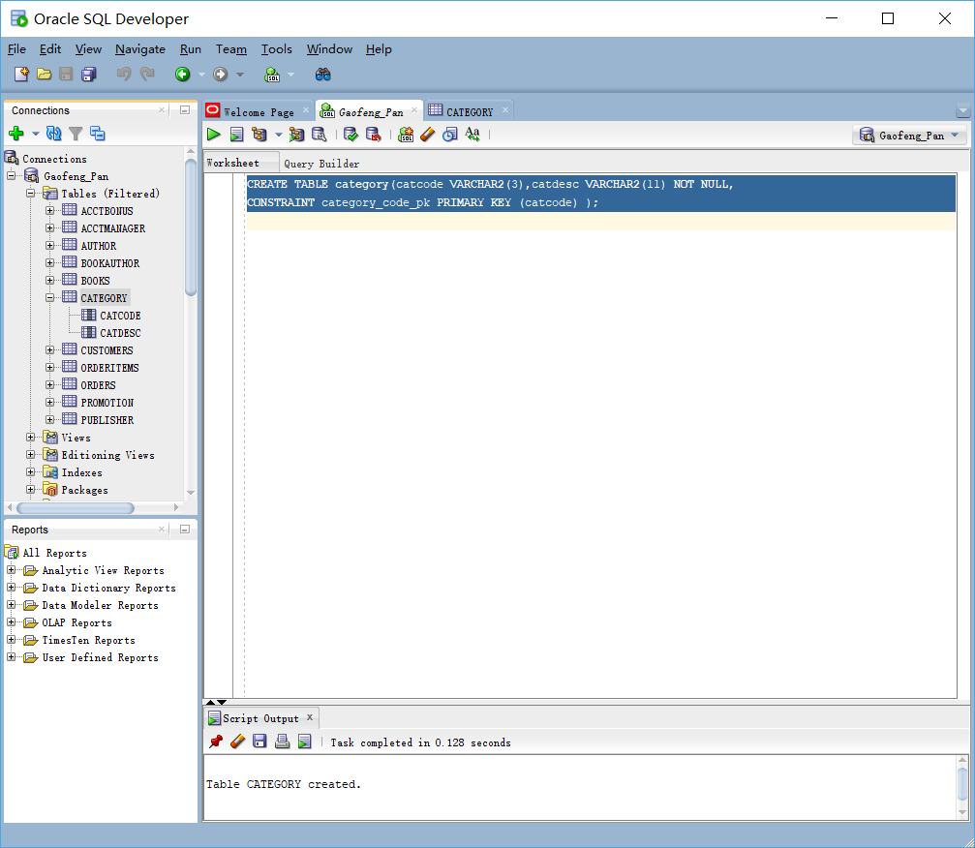

INSERT INTO category VALUES ('BUS', 'BUSINESS');

INSERT INTO category VALUES ('CHN', 'CHILDREN');

INSERT INTO category VALUES ('COK', 'COOKING');

INSERT INTO category VALUES ('COM', 'COMPUTER');

INSERT INTO category VALUES ('FAL', 'FAMILY LIFE');

INSERT INTO category VALUES ('FIT', 'FITNESS');

INSERT INTO category VALUES ('SEH', 'SELF HELP');

INSERT INTO category VALUES ('LIT', 'LITERATURE');

COMMIT;

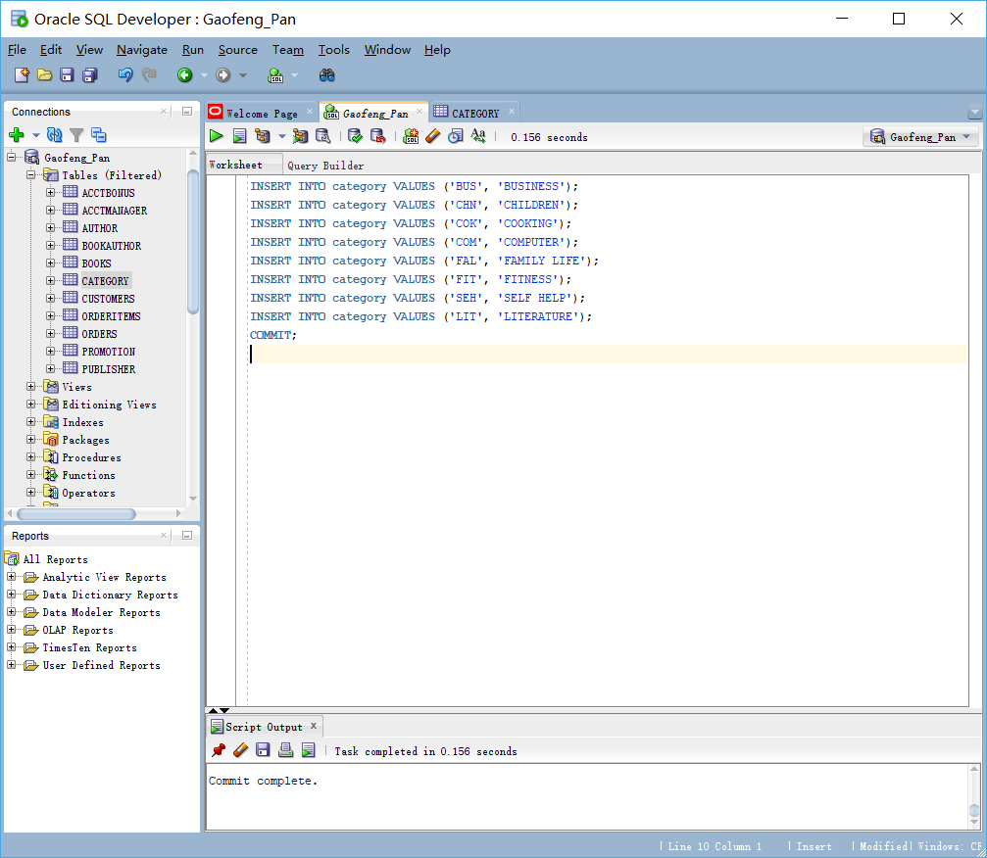

ALTER TABLE books ADD (catcode VARCHAR2(3),CONSTRAINT books_catcode_fk FOREIGN KEY (catcode)REFERENCES category(catcode));

UPDATE books SET catcode = 'BUS'WHERE category = 'BUSINESS';

UPDATE books SET catcode = 'CHN'WHERE category = 'CHILDREN';

UPDATE books SET catcode = 'COK'WHERE category = 'COOKING';

UPDATE books SET catcode = 'COM'WHERE category = 'COMPUTER';

UPDATE books SET catcode = 'FAL'WHERE category = 'FAMILY LIFE';

UPDATE books SET catcode = 'FIT'WHERE category = 'FITNESS';

UPDATE books SET catcode = 'SEH'WHERE category = 'SELF HELP';

UPDATE books SET catcode = 'LIT'WHERE category = 'LITERATURE';

COMMIT;

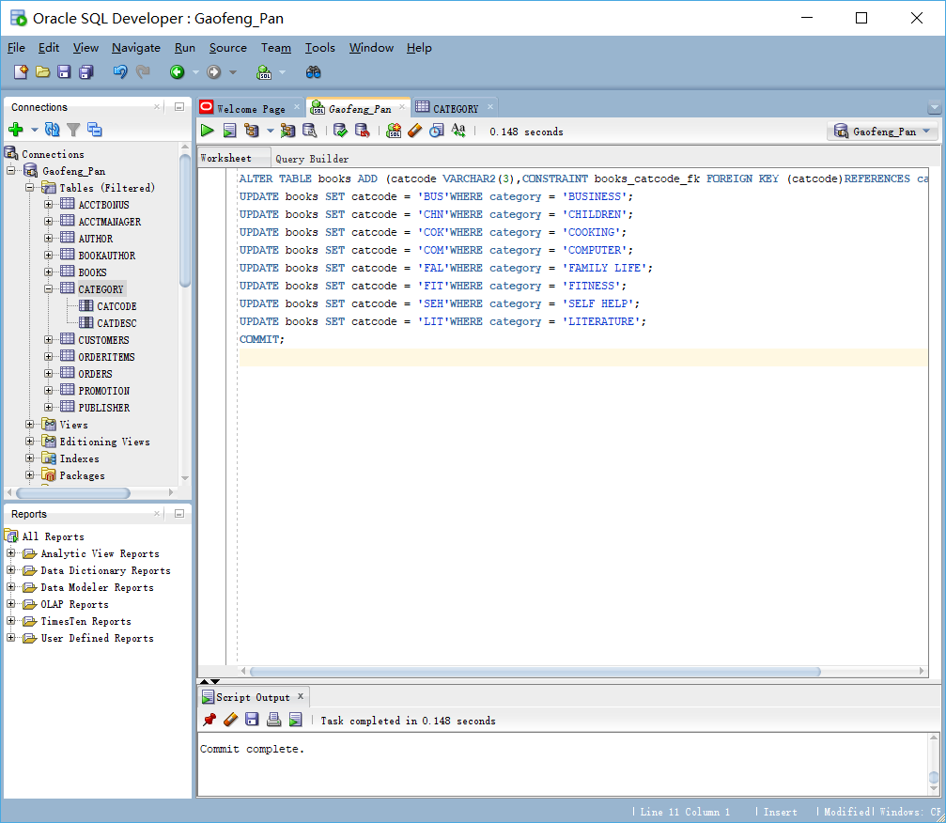

ALTER TABLE books DROP column category;

